Hyoungjun Lee  
3/27/20  
Computer org,Programming  
Project A4, Task 4

First, I wrote out fourth.s, and to do debug, I assemble it and linking the program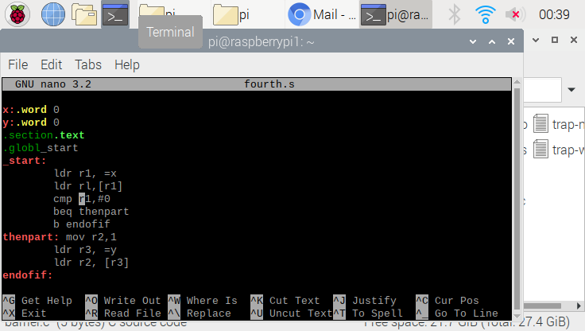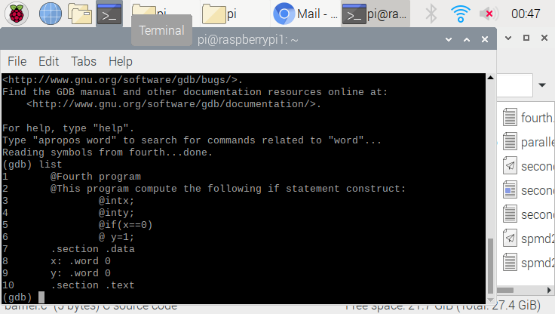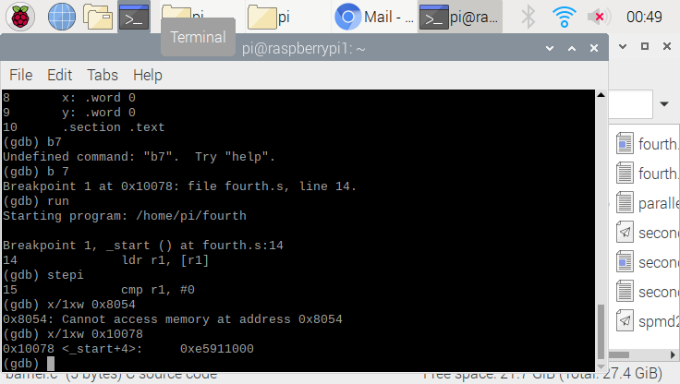

And I set up the break point at line 7, where the instruction started, and it will go through the whole program until .end

And using stepi, and x/1xw 0x10078 at the point, and hex value will be 0xe5911000

Part 2)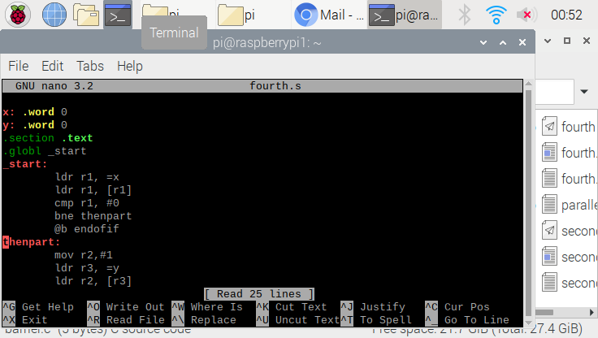improved code for fourth.s

We corrected code for the better look and efficiently to avoid back to back, we removed b and change beq to bne, using Demorgan’s law

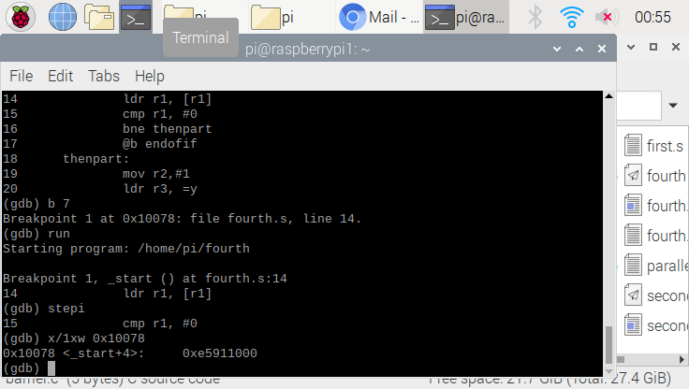

We compiled and link and debug

And we examining the flag using info register

My value of r2 is 0 as expected and zflag is 10, which is set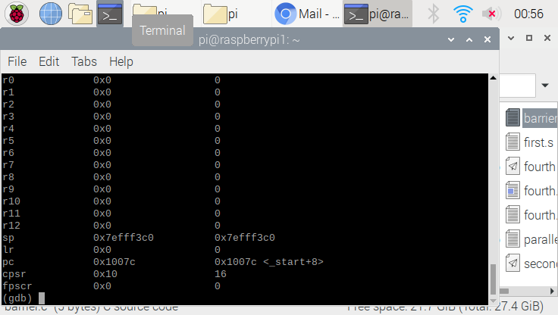

Part3

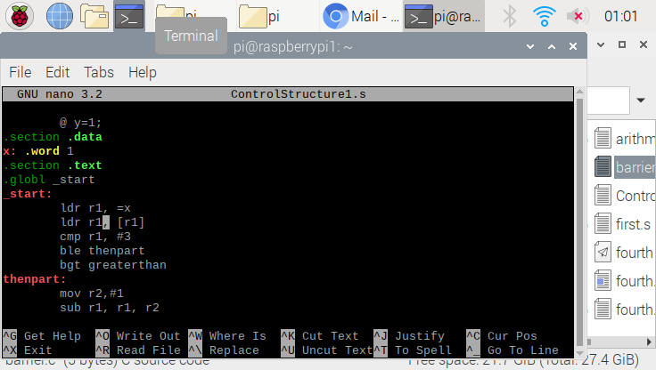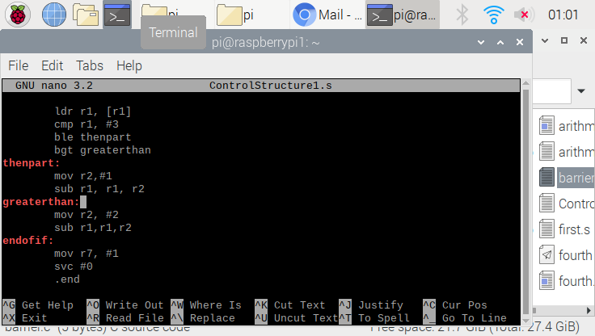

I wrote code above, breakpoint 7 and 19, and I examine the register after end of program

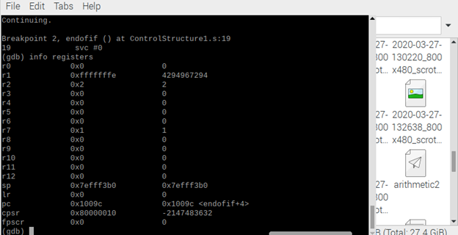

The value of zero flag is 0 in this example